ABOUT US

We are making clean and mobile transportation more accessible to everyone in other to create a sustainable society

Air pollution caused by gas exhaust from gasoline vehicles has become a serious problem causing many to cover their faces with masks while riding on the street. About 5.5 million people die prematurely each year due to air pollution with over half of those deaths occurring in China and India, two of the world’s fastest-growing economies.

The transition from traditional gasoline-powered vehicles to electric vehicles (EVs) has been a gradual process and an exciting leap for others. As innovation and awareness increase, EVs are not becoming cheaper, safer and healthier to own and operate.

Boasting features like onboard solar electric generators and driver-passenger safety algorithms, our Platform vehicles have lower fuel and maintenance costs. And consumers ultimately garner social pride and responsibility from creating a better, healthier planet. For all of these reasons and more, EVs have caught the attention of daily commuters. We at CavielTech plan to launch our first pilot programme in July 2022. With our onboard generator system, charging infrastructure, battery swapping technology, Hybrid EV power management system, and proprietary driver-passenger safety management system, we can ensure that our vehicles are power-packed to deliver the maximum value to our users while ensuring a stable and enabling environment with less pollution.

OUR VISION

Specifically, provide accessibility to power in rural areas

OUR GOAL

To accelerate the growth of sustainable transport by bringing compelling electric vehicles to market.

PRODUCTS/SERVICE

Hyb-Rick: A power-packed system that enables complete retrofitting of an existing vehicle into a hybrid vehicle. Book your appointment, drop off your vehicle for regular servicing and we will install our kit for you.

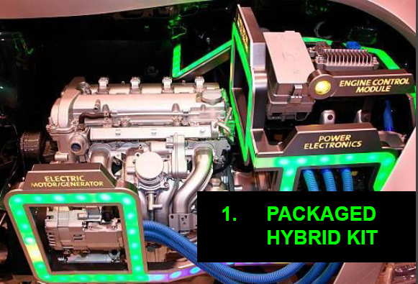

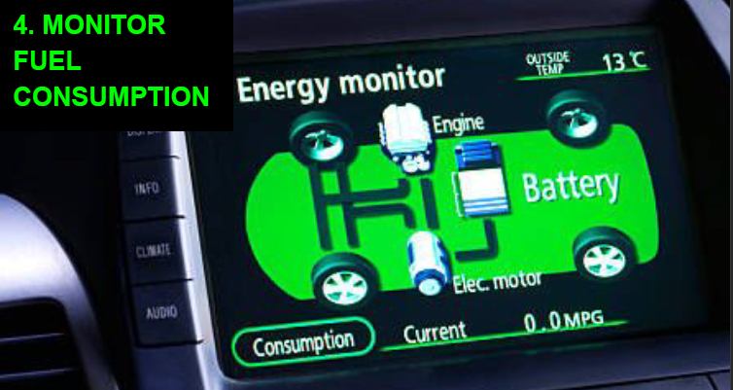

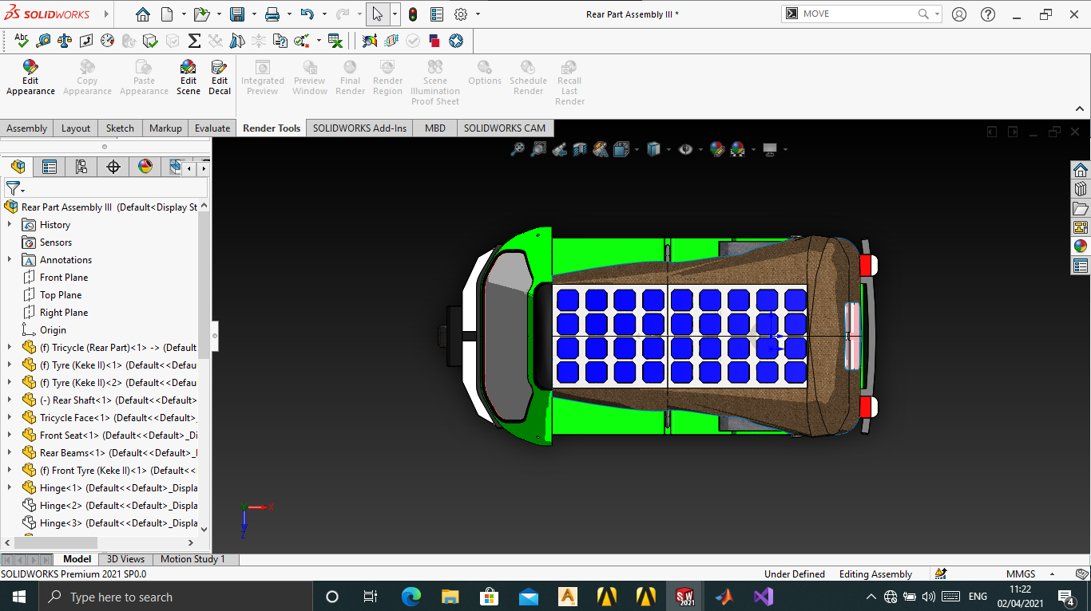

CONTACT US

Email: [cavieltech@gmail.com](mailto:cavieltech@gmail.com)

Phone number/WhatsApp: +16477850072

\*\*\*Would it be possible to create a web form on this page as well, where there is like three input boxes for their name, email and their questions or inquiry.

Address: (In progress)

NEWS/BLOG

This is where we would likely put in News or blog relevant to our product and industry at large